For immediate release
18th July 2023
Leeds Castle Offers Rare
Overnight Stay Experience in The Castle

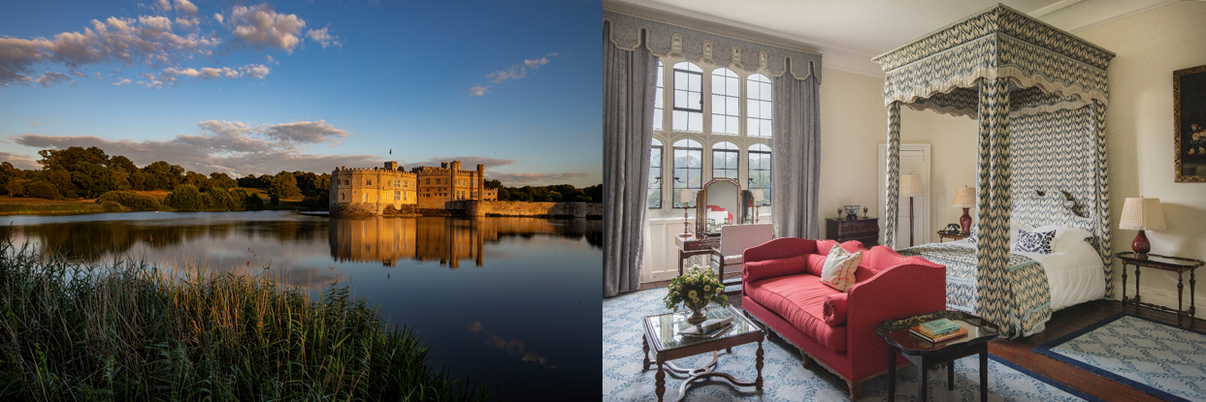

Leeds Castle, one of UK’s most cherished and iconic castles, is excited to announce a highly exclusive opportunity for its visitors. On selected dates throughout July and August, guests can now experience a fairy-tale come true with overnight stays in the castle's historic bedrooms, complete with an indulgent breakfast and dinner fit for royalty.

An experience like no other, staying in Leeds Castle promises a rare glimpse into the castle's captivating history. Nestled in the heart of the picturesque Kent countryside, Leeds Castle's heritage dates back over 900 years, making it the ultimate getaway for history enthusiasts, milestone celebrations, and those seeking a truly extraordinary experience.

Guests can choose to stay in the Castle’s State Bedrooms where Lady Baillie’s guests, including the Duke and Duchess of Windsor, Winston Churchill and even Charlie Chaplin once stayed, transporting them back in time to a realm of regal grandeur and uncompromising luxury. Or they can opt for the more ‘Downton’ experience and stay in the Battlement Bedrooms which were designed to house the staff of Lady Baillie’s guests.

After a day spent exploring Leeds Castle’s over 500 acres of seasonal gardens and parkland, thrilling events and attractions, and discovering its captivating history, guests can retreat to their castle bedrooms, adorned with timeless elegance. Embrace the comfort and luxury of yesteryears, soak in the ambiance, and discover a tranquil respite where charm and history merge effortlessly.

The exceptional experience doesn’t stop there. With this exclusive offer, guests will be treated to a sumptuous two-course dinner in the renowned Castle View Restaurant. They will sample the latest seasonal menu with locally sourced produce, expertly prepared by talented chefs, while gazing upon breath-taking views of Leeds Castle.

As the sun rises over the Castle’s majestic turrets, guests head back to the Castle View Restaurant to enjoy a delicious breakfast, served with warmth and elegance. They will sip their morning coffee and take a bite of delectable pastries as they relish the tranquil beauty surrounding them.

This rare and exclusive opportunity to stay overnight in Leeds Castle’s Castle bedrooms is not to be missed. Don’t let this chance slip away – book your stay now and join the privileged few who have discovered this unforgettable glamour of Leeds Castle.

With a limited number of rooms available on selected dates, early booking is highly recommended to secure this extraordinary journey into the past. Reservations can be made directly through the Leeds Castle official website at www.leeds-castle.com/stay. Dates available for July and August include 23rd, 24th, 25th, 26th, 27th, 28th and 29th July, and 5th, 6th, 7th, 8th, 9th, 10th, 11th, 13th, 16th, 17th, 18th 20th, 21st, 22nd, 23rd, 24th, 25th, 28th, 29th, 30th, 31st August 2023.

Prices start from £365 for a Battlement Bedroom, and from £460 for a State Bedroom. Based on two people sharing. The package includes one night stay in the Castle, two-course dinner in the Castle View Restaurant and a hearty breakfast the following morning.

- ENDS -

For press requests, please contact Nicole Moor at nicolemoor@leeds-castle.co.uk

About Leeds Castle

Leeds Castle is considered a national treasure, providing a window onto over nine hundred years of British history. It is a haven of tranquillity and offers a wealth of discovery and enjoyment for all ages.

Situated five miles southeast of Maidstone in Kent, Leeds Castle’s rich and riveting history, including serving six of England’s medieval queens, to its elaborate transformation into a glamorous 1930s country house retreat for the influential and famous by Anglo-American heiress, Lady Olive Baillie, secures its place as one of the most visited historic attractions in Britain.

The Castle and its estate is preserved and maintained by the Leeds Castle Charitable Foundation, a not-for-profit charity

For more visitor information, please visit www.leeds-castle.com
- Leeds Castle, Broomfield, Maidstone ME17 1PL
- Telephone 01622 765 400 or email enquiries@leeds-castle.co.uk

